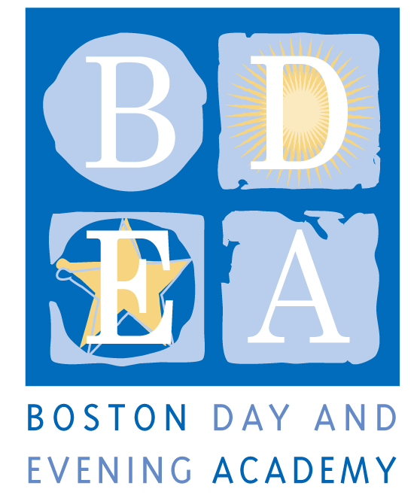
Boston Day & Evening Academy
A Horace Mann Charter School
Program Associate Job Description
School Year 2019-20

Boston Day and Evening Academy (BDEA) is seeking an extraordinary Program Associate to work in our school. BDEA is an innovative public high school whose mission is to serve students who are overage for grade level, many of whom have experienced life challenges that have impeded their education. Working with experienced faculty in an environment that blends strong academics and support, students are given the opportunity to earn a Boston Public Schools diploma and to reach their fullest potential through a competency-based curriculum that inspires critical and creative thinking, independent learning, and active citizenship. As a competency-based school, BDEA does not have grade levels. Our extended program, beginning at 8:00 am and running until 4:30 pm serves students with different academic needs up to age 23, including those who are being promoted from middle school without being academically prepared for high school; those who have dropped out of high school and have decided to return to earn a diploma, and those who are unable to attend regular school hours due to health issues, full time work and/or full time parenting obligations. The school employs 50 full and part-time staff to work with 405 students and is governed by an active Board of Trustees.

The Program Associate will responsibilities will cover two main areas: support of the school’s enrichment program and support of the office of institutional advancement. We are looking for a staff member who is committed to working with our students, who understands the lives of urban youth and who has a track record of working successfully in a collaborative professional learning community.

Responsibilities
Support Institutional Advancement
- The Program Associate will work with the advancement director to support the dissemination of clear, cohesive, and accurate information about Boston Day and Evening Academy to all of the school’s constituents and audiences including but not limited to: students, families, staff, Boston Public Schools (BPS), the Department of Elementary and Secondary Education (DESE), curriculum partners, community partners, funders, and the board of trustees. To that end, the Program Associate will enhance the school’s social media footprint and weave together its web site, Facebook and Twitter platforms, to create guidelines for its effective use by leadership and other staff, and to monitor and update its effectiveness for communicating our practice. The Program Associate will us their understanding of social media platforms to enhance the functionality of the school’s web site.
- Support Advancement Director with fundraising appeals and events and assist at times with small aspects of grant management and grant reporting when needed.
- Oversee the process of logging donor and all other income information into the new SalesForce Platform, keeping data accurate, running reports, and assuring that all donations and gifts are acknowledged.
- Assist Director of Operations, Director of Post Graduate Planning and Director of Advancement, with running annual events at the school including the summer institute (REAL) and four annual graduations (September, December, April, and June).
- Contribute to the quarterly e-letter by writing articles and taking photos and keeping the mailing list updated.
- Attend Board of Trustee’s meetings and assume responsibilities of board clerk.

Enrichment Program Coordination
- Work collaboratively with Instructional leader, Director of Operations and Head of School to coordinate BDEA’s enrichment program. This includes:
  - Working with Head of School to identify staff or partners to teach courses,
  - Supporting Instructional Leader’s coordination of quarterly professional development workshops for enrichment staff
  - Monitoring enrichment staff bi-monthly timesheets,
  - Collaborate with Instructional Leader to create a trimester enrichment course schedule that meets needs of student interests and meshes with academic courses,
  - Work with BDEA advisors and students to ensure courses are filled,
  - Work with Director of Operations to monitor budget spending for enrichment coursees

- Support the Data and Accountability Manager with management of assessment and data requirements of enrichment program.

- Perform other related duties as determine by Head of School to assure smooth school functioning.

Terms: Managerial (B) Full-time
As a Horace Mann Charter School, teachers and staff are paid a competitive salary in accordance with the Boston Public Schools. The position is an 11-month, 40 hours/week management position. The employee will be required to adhere to the work conditions, including calendar, schedule and flexibility established by the School. The work schedule will be set by the staff member and the head of school according to school needs. Other benefits include Medical and Dental benefits, eligibility for City of Boston retirement. This position is subject to City of Boston Residency requirement
Qualifications

Required:
- Bachelor’s or more advance Degree
- Tech-savvy in various computer applications: Salesforce, database, web design programs, social media etc.
- Knowledge and comfort in the use of social media (Twitter, Facebook)
- Have excellent communication and organizational skills; Bilingual Spanish, Creole, other: a strong plus
- Acute attention to detail and project completion
- Strong and tested ability to participate effectively on teams; have collaborative management style
- Passion for coordinating multiple “moving parts” (logistics, schedule, people, etc.)
- Ability to work in a fast-paced, challenging environment
- Be able to interact with young people and their families in a respectful and caring manner
- Adhere to BDEA’s Non-Discrimination Policy (see below)
- A sense of humor!

Application Procedure
Apply through Boston Public Schools’ Human Capital website: http://bostonpublicschools.org/Page/4637 as well as send directly to BDEAopenings@gmail.com.

Boston Day and Evening Academy, in accordance with its non-discrimination and zero tolerance policy, does not discriminate in its programs, activities, facilities, employment and educational opportunities on the basis of race, color, age, disability, sex/gender, gender identity or expression, religious beliefs, home status, national origin, ancestry, sexual orientation, genetics or military status and does not tolerate any form of intimidation, threat, retaliation, coercion and/or harassment that insults the dignity of others and interferes with their freedom to learn or work.

