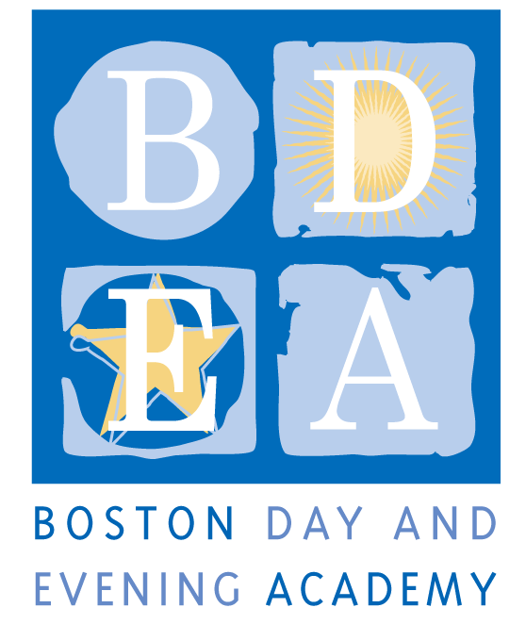
Boston Day & Evening Academy- 2.0
A Horace Mann Charter School
Humanities Teacher Job Description
School Year 2019-20

Boston Day and Evening Academy (BDEA) is seeking an extraordinary Humanities Teacher excited to be a lead designer and educator in a new BDEA program (BDEA 2.0) designed specifically for young men of color who have been underserved/discouraged in traditional schools, and who are disenfranchised from even the possibility of graduation. BDEA is an innovative public high school whose mission is to serve students who are overage for grade level, all of whom have experienced interruptions to their education.

We are looking for educators eager to challenge the norm, to assist a committed team in building a new pathway for the city’s most marginalized students, and to embrace with us the following mission statement, core values and guiding principles for instruction.

BDEA 2.0 Mission Statement:
We are a student-led community. We collaborate to create meaningful learning experiences that give us the freedom to grow academically, develop agency, learn about ourselves, and acquire the skills to achieve our vision for the future.

Core Values:
In our community, consistently
- We have each other’s back  - We are authentic and open with each other  - We value transparency, integrity, and trust  - We demonstrate mutual respect  - We challenge mediocrity by setting high expectation for ourselves  - We honor self-growth and development  - We hold each other accountable  - We inspire and motivate each other | - We build responsibility and independence through collaboration and shared leadership  - We acknowledge the historical and present racial, cultural, and economic discrimination all around us, and we commit to leading change in creating equity.  - We help each other navigate and thrive in the world  - We promote versatility and adaptability

Guiding principles:
To provide students with relevant and engaging learning and life skills experiences, we will consistently provide:
- Relevant curriculum and “learning that sticks”
- Out-of-school learning opportunities
- A balance between self-paced and social learning
- An environment that understands that relationships are central and integrated with student supports
- Varied opportunities to meet competency assessments, i.e., service learning, project-based learning, internships.
- A community that supports learning as transparent and consistent
- Opportunities to build student agency, leadership, empowerment, self-knowledge, and vision for the future
- A consistent expectation that all staff meet students where they are (emotionally, academically)

BDEA staff must demonstrate a commitment to working with urban youth and have a track record of working successfully with students who have faced ongoing academic and personal challenges. BDEA staff are expected to build strong relationships with students and provide consistent support through academic classes, enrichment activities, and a daily Crew. Staff work collaboratively to develop and teach a competency-based curriculum, providing opportunities for students to exhibit proficiency in multiple ways including through projects, exhibitions and other alternative means of assessment.

Responsibilities
- Teach project-based, interdisciplinary units of study during morning block, and provide small group or individual academic support during the afternoon in self-paced learning labs.
- Co-lead an advisory (crew) of up to 17 students. The crew comprises students and staff who build community through team-building activities, and create ownership of learning by facilitating communication between the student, his or her peers, family, and other staff. Collectively, the crew will be empowered to support one another, monitor one another’s attendance, academic progress, and overall student wellness.
- Create and maintain accurate record keeping of student academic progress and attendance on all data systems, e.g., PowerSchool and BDEA CONNECTS.
- Collaborate with other teaching staff to develop interdisciplinary and project-based curricula and alternative assessments such as portfolios and exhibitions.
- Assist the special education coordinator with the development and implementation of individual student learning plans including special education plans (IEPs and 504s).
- Participate in the development of student exhibitions for both academic and career readiness competencies, Portfolio Reviews, and other community and all-school events.
- Participate in weekly program-specific and all-school meetings.
- Participate in all professional development and curriculum planning activities.
- Support and coach students to obtain passing or better score on the MCAS and other required assessments.
- Assist in developing independent projects for students in the blended and learning lab program.
- Perform other related duties to assure a continued safe, supportive school culture and climate

Terms: BTU Group I, Full-time
As a Horace Mann Charter School, teachers and staff are paid a competitive salary in accordance with the Boston Public Schools. As a condition for employment, BDEA staff are required to sign an Election to Work Agreement (ETWA) annually, which details the terms and conditions for the work year at the school. While the school generally follows the BPS calendar, it requires additional planning time before, after or during the year, as agreed upon in the ETWA. Staff hours are from 8:15-3:15 pm, Monday thru Fridays. On Wednesday and Fridays, common planning time and self-directed curriculum development is 8:15am - 1:15 pm. Department, committee meetings, and professional development take place on Wednesdays and Fridays, generally between 1:30-3:15 pm.

Qualifications
Required: A successful candidate will …
- Have a secondary content area certification in the State of Massachusetts. (see www.doe.mass.edu for requirements) for ELA
- Have dual certification in Special Education and/or ESL
- Possess the core competencies of excellent teaching including charisma, compassion and intellectual curiosity
- Comfortable with a workshop and/or coaching approach to instruction
- Interact with all students with respect and care
- Be student/learning-centered and committed to coaching students towards success
- Commitment to designing and implementing a competency based curriculum
- Be able to assess student competence using a variety of assessments
- Create a learning environment that supports student agency, collaboration, peer engagement, and creative discourse
- Have the ability to teach to multiple learning styles using a variety of methods
- Have a commitment to working with the families of our students
- Adhere to BDEA’s Non-Discrimination Policy (see below)

Preferred:
- Masters Degree a strong plus
- Prior work or volunteer experience with non-traditional students in an alternative setting
- Experience with any of the following: project-based learning, portfolio assessment, competency-based education, cooperative group work, integration of technology and cross-disciplinary learning, expeditionary learning, alternative assessments, and integrating school-to-career experiences into the curriculum
- A strong commitment to supporting reading, writing and problem solving across the curriculum
- A sense of humor

Application Procedure
Apply through Boston Public Schools’ Human Capital website: http://bostonpublicschools.org/Page/4637

Boston Day and Evening Academy, in accordance with its non-discrimination and zero tolerance policy, does not discriminate in its programs, activities, facilities, employment and educational opportunities on the basis of race, color, age, disability, sex/gender, gender identity or expression, religious beliefs, national origin, ancestry, retaliation, sexual orientation, genetics or military status and does not tolerate any form of intimidation, threat, coercion and/or harassment that insults the dignity of others and interferes with their freedom to learn or work.

