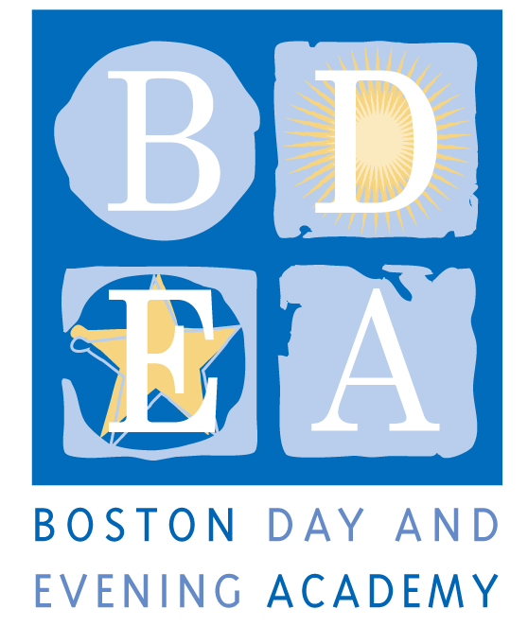
The Boston Day & Evening Academy
Horace Mann Charter School
Seeks a Student Admissions Manager
School Year 2018-19

Boston Day and Evening Academy (BDEA) is seeking an extraordinary Admissions Manager to work in our school. BDEA is an innovative public high school whose mission is to serve students who are overage for grade level, many of whom have experienced life challenges that have impeded their education. Working with experienced faculty in an environment that blends strong academics and support, students are given the opportunity to earn a Boston Public Schools diploma and to reach their fullest potential through a competency-based curriculum that inspires critical and creative thinking, independent learning, and active citizenship. As a competency-based school, BDEA does not have grade levels. Our extended program, beginning at 8:00 am and running until 4:30 pm serves students with different academic needs up to age 23, including those who are being promoted from middle school without being academically prepared for high school; those who have dropped out of high school and have decided to return to earn a diploma, and those who are unable to attend regular school hours due to health issues, full time work and/or full time parenting obligations. The school employs 50 full and part-time staff to work with 405 students and is governed by an active Board of Trustees.

We are looking for an individual who is committed to working with our students, who understands the lives of urban youth and who has a track record of working successfully with students who face academic and personal challenges, all within a Youth Development approach. The Student Admissions Manager will be the lead staff member to oversee all student recruitment, initiating and maintaining excellent rapport and relations with all local middle and high schools and community organizations in order to ensure full enrollment throughout the year. The Student Admissions Manager will also work closely with the Student Support Team to ensure a smooth transition for all new students as they adapt to their new school.

Job responsibilities and duties:
- Work with the Office of Institutional Advancement to review and revise (if needed) student recruitment PR materials and media for outreach efforts, for use at events and for developing relationships with agencies that can/will refer students to BDEA.
- Conduct appropriate outreach to and communication with Boston Public Middle and High Schools, the Re-engagement Center, other community centers, media and community based organizations in order to recruit students.
- Identify and recruit appropriate (fitting within our mission) students for BDEA throughout the school year, assuring that the school maintains appropriate number of students in each program every trimester.
- Conduct new student 4-day, end of trimester orientations, including during the summer, to ensure full enrollment. Orientations are focused on familiarizing new students with student-centered, competency-based teaching and assessment, school culture, climate, and expectations, and on conducting initial assessments.
- Maintain accurate student recruitment data and records.
- Oversee intake process to assure students transition smoothly into the BDEA culture.
- Work collaboratively with Registrar’s Office to assure smooth intake.
- Communicate regularly with administration through formal and informal reporting regarding progress and informing administration.
- Monitor retention data as it pertains to the recruitment of students.
- Attend weekly Student Support Team meetings when possible and work collaboratively with the SST to ensure students are attending on a regular basis.
- Other duties as requested by Head of School.
Terms
Status: (Full-time) Managerial, Tier B, Step to be set according to candidate’s experience; 223 work days between July 1st and June 30th each year. As a Horace Mann Charter School, employees are paid a competitive salary in accordance with the BPS managerial scale. The employee will be required to adhere to the work conditions, including calendar, schedule and flexibility established by the School. Common planning time, program, department and committee meetings, and professional development take place on Wednesday and Friday generally between 1:30pm and 3:30pm. Other benefits include Medical and Dental benefits, eligibility for City of Boston retirement. This position is subject to City of Boston Residency requirement.
Qualifications (Required)
- Has a bachelor’s degree
- Has a youth development background (including teaching and/or training) and enjoys working with students who have not experienced success in school.
- Has experience in conducting experiential lessons, administering assessments, and teaching groups of as many as 30 young people.
- Has demonstrated leadership experience, interpersonal skills and personal characteristics necessary for working effectively with students, teachers, administrators and parents
- Has excellent oral and written communication, computer and organizational skills
- Knowledge and comfort in the use of social media (Twitter, Facebook, text messaging)
- Has experience establishing a collaborative, team-oriented atmosphere that honors diversity and enhances individual and community growth
- Has experience working in a fast-paced, challenging environment
- Is able to be flexible, non-judgemental and is a creative problem solver.
- Adhere to BDEA’s Non-Discrimination Policy (see below)

Preferred (one or more)
- Bilingual in Spanish, Cape Verdean or Haitian Creole a strong plus.
- Has teaching experience and curriculum development work
- Has experience working with a variety of community organizations and resources
- A sense of humor

Application Procedure
Apply through Boston Public Schools’ Human Capital website: http://www.bostonpublicschools.org/domain/19 , as well as send directly to BDEAopenings@gmail.com.

Boston Day and Evening Academy, in accordance with its non-discrimination and zero tolerance policy, does not discriminate in its programs, activities, facilities, employment and educational opportunities on the basis of race, color, age, disability, sex/gender, gender identity or expression, religious beliefs, national origin, ancestry, retaliation, sexual orientation, genetics or military status and does not tolerate any form of intimidation, threat, coercion and/or harassment that insults the dignity of others and interferes with their freedom to learn or work.

