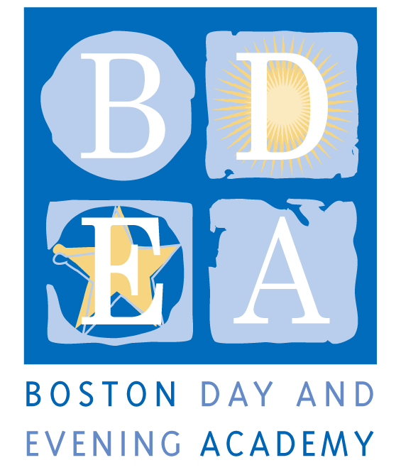
The Boston Day & Evening Academy
Horace Mann Charter School
Social Worker/Coordinator
School Year 2018-19

Boston Day and Evening Academy (BDEA) is seeking an extraordinary Social Worker to work in our school. BDEA is an innovative public high school whose mission is to serve students who are overage for grade level, many of whom have experienced life challenges that have impeded their education. Working with experienced faculty in an environment that blends strong academics and support, students are given the opportunity to earn a Boston Public Schools diploma and to reach their fullest potential through a competency-based curriculum that inspires critical and creative thinking, independent learning, and active citizenship. As a competency-based school, BDEA does not have grade levels. Our extended program, beginning at 8am and running until 4:30pm serves students with different academic needs up to age 23, including those who are being promoted from middle school without being academically prepared for high school; those who have dropped out of high school and have decided to return to earn a diploma, and those who are unable to attend regular school hours due to health issues, full time work and/or full time parenting obligations. The school employs 50 full and part-time staff to work with 405 students and is governed by an active Board of Trustees.

We are looking for a social worker that is committed to working with our students, who understands the lives of urban youth and who has a track record of working successfully with students who face academic and personal challenges. BDEA teachers and staff are expected to support students both academically and personally through academic classes, enrichment activities, a daily advisory period and an effective array of supports primarily offered by Student Support Team (SST) members. The Social Worker works with a robust Student Support team to provide specific social emotional support for students and makes effective use of partnerships to provide an array of responsive services to the varied needs of our student population.

Responsibilities
- Have working knowledge of Positive Behavior Intervention Supports (BPIS) and be able to collaborate with the staff to ensure social emotional needs of students are being met; perform classroom observations; provide teachers support in understanding triggers and coping strategies through conducting classroom observations.
- Match students with appropriate services, monitor their progress and coordinate follow-up services for students on case load
- Act as a caseworker for specific students; collaborate with teaching staff around student academic progress, gather paperwork, homework assignments for students who may have interruptions due to temporary tutoring, outside hospitalization or partial program placement.
- Provide counseling services both individually and small group
- Serve as a liaison between the school, student, parent and external agencies.
- Create Behavior Intervention Plans (BIP) and Functional Behavior Assessments (FBA) for students specifically identified by Special Education Coordinator
- Plan and implement school support programs in collaboration with the student support team, special education coordinator and leadership, attend all SST meetings
- Make referrals to external agencies and appropriate programs for students in need of support services
- Support Director of Student Support and Special Education to include crisis interventions, creation of safety plans (suicidal, high social/emotional needs), apply social service interventions by referring to external agencies when appropriate and call BEST team and follow through as needed.
- Conduct home visits when appropriate for case load

- Attend all IEP meetings for students on case load or for students that may need services, write IEP goals for students in need of counseling or group services
- Participate in all professional development and whole school retreats and activities.
- Enter and update daily student data and information in BDEA Connects and other BDEA systems to share and track information.
- Engage in best practices and professional standards of care.
- Model professional behaviors that contribute to addressing the needs of students, families, and the school community.
- Perform other related duties as requested by the Administrative Team to assure smooth school functioning

Terms: BTU Group I, (full time)
As a Horace Mann Charter School, teachers and staff are paid a competitive salary in accordance with the Boston Public Schools. As a condition for employment, BDEA staff are required to sign an Election To Work Agreement (ETWA) annually, which details the terms and conditions for the work year at the school. While the school generally follows the BPS calendar, it requires additional planning time before, after or during the year, as agreed upon in the ETWA (up to 194 days). The Social Worker hours will be 9-4pm Monday-Friday. However, hours may vary according to student needs. Common planning time, program, department and committee meetings, and professional development take place on Wednesday and Fridays, generally between 1:30- 3:30pm.

Please refer to www.bostonpublicschools.org/ohc (under "Employee Benefits and Policies") for more information on salary and compensation. Salaries are listed by Unions and Grade/Step.

Qualifications

Required:
- Current MA Board of Registration Social Worker license (LSW, LCSW or LICSW) OR psychologist license OR mental health clinician license (LMHC)
- A Masters Degree in social work, psychology or counseling education or related field
- Minimum of three years professional experience working with at-risk youth
- Bilingual in Spanish, Haitian Creole, or Cape Verdean Creole a strong plus
- Strong interpersonal skills to work with school, students, parents and community based agencies
- Experience successfully working with non-traditional students in an urban, alternative setting
- The ability to connect to and work with students using a variety of methods while always maintaining a respectful and caring manner
- Ability to motivate and inspire a diverse set of stakeholders toward a common goal.
- The ability to establish a multicultural and multigenerational atmosphere at BDEA, including a strong commitment to working with the families of our students and with our parenting students.
- Adhere to BDEA’s Non-Discrimination Policy (see below)
- A sense of humor

Application Procedure
Apply through Boston Public Schools’ Human Capital website: http://bostonpublicschools.org/Page/4637

Boston Day and Evening Academy, in accordance with its non-discrimination and zero tolerance policy, does not discriminate in its programs, activities, facilities, employment and educational opportunities on the basis of race, color, age, disability, sex/gender, gender identity or expression, religious beliefs, home status, national origin, ancestry, sexual orientation, genetics or military status and does not tolerate any form of intimidation, threat, retaliation, coercion and/or harassment that insults the dignity of others and interferes with their freedom to learn or work.

