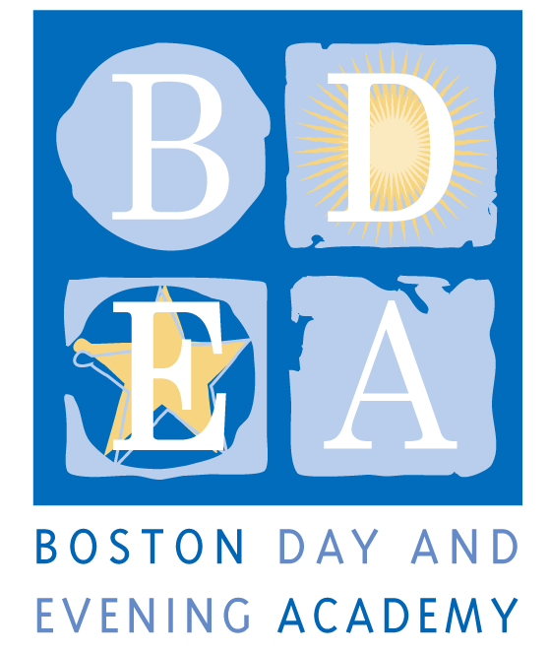
The Boston Day & Evening Academy
Horace Mann Charter School
Community Field Coordinator
Job Description
School Year 2018-19

Boston Day and Evening Academy (BDEA) is seeking an extraordinary Community Field Coordinator to work in our school. BDEA is an innovative public high school whose mission is to serve students who are overage for grade level, many of whom have experienced life challenges that have impeded their education. Working with experienced faculty in an environment that blends strong academics and support, students are given the opportunity to earn a Boston Public Schools diploma and to reach their fullest potential through a competency-based curriculum that inspires critical and creative thinking, independent learning, and active citizenship. As a competency-based school, BDEA does not have grade levels. Our extended program, beginning at 8:00 am and running until 4:30 pm serves students with different academic needs up to age 23, including those who are being promoted from middle school without being academically prepared for high school; those who have dropped out of high school and have decided to return to earn a diploma, and those who are unable to attend regular school hours due to health issues, full time work and/or full time parenting obligations. The school employs 50 full and part-time staff to work with 405 students and is governed by an active Board of Trustees.

We are looking for a staff member who is committed to working with our students, who understands the lives of urban youth and who has a track record of working successfully with students who face academic and personal challenges. BDEA staff members are expected to support students both academically and personally through academic classes, electives, enrichment activities and a daily advisory period. BDEA staff members also work collaboratively to develop and teach a competency-based curriculum where students exhibit proficiency in multiple ways including projects, exhibitions and other alternative assessments. The CFCs role is to provide a supportive bridge that allows for students’ social/emotional and personal growth so that they can excel in their academic development.

Responsibilities
- Collaborate with the staff, SST Coordinator to establish and maintain a positive, peaceful and safe culture at BDEA.
- Work closely with the Student Support Coordinator to oversee and help maintain the social, emotional health and safety of the student body.
- Work closely with community-based organizations to support students, their families and work towards optimum health.
- Assist with the safe transition of students between classes, before and after school.
- Participate in student admissions process, including screening applicants, conducting student and parent tours of the school, and coordinating new parent orientations.
- Assist advisors and school administrators in communicating with the parents of students identified through that process.
- Attend trainings and workshops designed to increase expertise in the impact of trauma on learning and behavior, behavior modification, youth development, and involvement of the parent community.
- Monitor student attendance and implement procedures to address concerns regarding attendance.
- Facilitate topic-specific groups, such as Young Women’s, sexual exploitation, men’s group, parenting, adventure, and youth leadership development.
- Enter and update student data and information in Connects (Sales Force) and other BDEA systems to share and track information
- Make home visits to students and families as needed, in support of student attendance, and to ensure 100% participation in state assessments.
- Attend weekly student support and program meetings.
- Facilitate weekly student peer-support groups.
- Supports the before and after school programs in the building, including maintaining the security of the building.
- Participate in the development and success of Symposium, Portfolio Reviews, Garden Day and other community and all-school events.
- Participate in all professional development and whole school retreats and activities.
- Participate in student disciplinary meetings and coordinate peer mediation program.
- Facilitate student referrals to other more appropriate programs, if they are withdrawing from BDEA.
- Perform other related duties as requested by the Administrative Team.

Terms: BTU, Full-time
As a Horace Mann Charter School, teachers and staff are paid a competitive salary in accordance with the Boston Public Schools. As a condition for employment, BDEA staff are required to sign an Election To Work Agreement (ETWA) annually, which details the terms and conditions for the work year at the school. While the school generally follows the BPS calendar, it requires additional planning time before, after or during the year, as agreed upon in the ETWA. CFC hours are from 9:00 – 4:30 pm with 30 min lunch, Monday through Thursday and 9:00 – 4:00 pm on Fridays. However, hours may vary according to student needs. Common planning time, program, department and committee meetings, and professional development take place on Wednesday and Friday generally between 1:30pm and 3:30pm

Qualifications

Required:
- Associates degree
- Excellent verbal and written communication skills
- Tech-savvy in various computer applications, such as Microsoft Office
- Ability to create an environment which will promote individual growth and a positive self-image
- Ability to work in a fast-paced environment
- Proven experience working with young people in a respectful and caring manner
- Be student-centered and committed to coaching students towards success, devoting additional time if necessary
- Have a commitment to working with the families of our students and with parenting students
- Adhere to BDEA’s Non-Discrimination Policy (see below)

Preferred:
- Bilingual Spanish, Creole, other: a strong plus
- Associate Degree
- Familiarity with students’ neighborhoods and safety issues
- A sense of humor

Application Procedure
Apply through Boston Public Schools’ Human Capital website: http://www.bostonpublicschools.org/domain/19

Boston Day and Evening Academy, in accordance with its non-discrimination and zero tolerance policy, does not discriminate in its programs, activities, facilities, employment and educational opportunities on the basis of race, color, age, disability, sex/gender, gender identity or expression, religious beliefs, home status, national origin, ancestry, sexual orientation, genetics or military status and does not tolerate any form of intimidation, threat, retaliation, coercion and/or harassment that insults the dignity of others and interferes with their freedom to learn or work.

