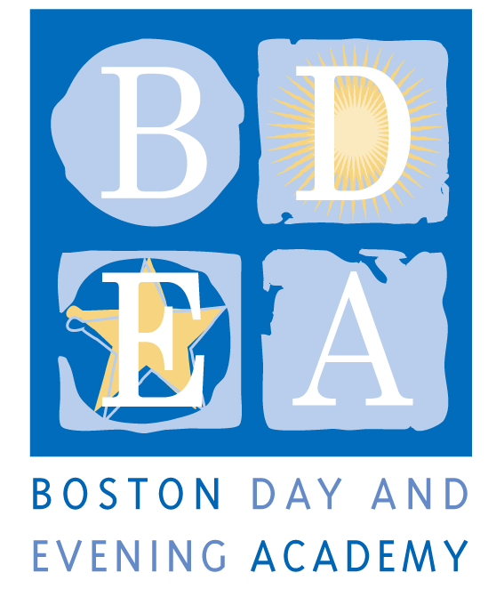
The Boston Day & Evening Academy
Horace Mann Charter School
Seeks a Urban Garden Coordinator

BDEA is an innovative public high school whose mission is to serve students who are overage for grade level, many of whom have experienced life challenges that have impeded their education. Working with experienced faculty in an environment that blends strong academics and support, students are given the opportunity to earn a Boston Public Schools diploma and to reach their fullest potential through a competency-based curriculum that inspires critical and creative thinking, independent learning, and active citizenship.

As a member of the Boston Day and Evening Academy (BDEA) community, the Garden Coordinator plays an integral part in the maintenance of the school’s community garden. This position requires a commitment to planning, planting, and harvesting the garden, and to teaching high school-aged students how to grow food.

Salary Range: approximately $20-25 dollars/hour (depending on experience)

Essential Job Functions: (30hrs/week)
April – June:
- Prepare the school’s garden beds (approx: 5-10hrs/week) for planting.
- Support BDEA staff in hiring student gardeners for the summer program
- Review summer program requirements, logistics and paperwork with Summer Coordinator
July 5th- August 10th
- Supervise and motivate a group of students aged 16-17 on how to properly cultivate an organic garden (weeding, planting and harvesting vegetables). 8:30 a.m. to 2:00 pm with 30 minute lunch break, Monday-Thursday.
- Create a 6-week work plan and motivate students to show up every day and accomplish tasks
- Keep track of timesheets, work performance and all other paperwork
- Develop and lead an additional educational project such as creating a healthy foods cookbook, art project, math construction project, or creation of a neighborhood food distribution network.
- Coordinate field trips to urban gardens, farms, and other engaging sites
- Assist in the maintenance of the garden’s shared space, tools, and infrastructure
- Write a brief final summary of the project at end of the summer

Qualifications:
- Three or more years working with youth as an educator.
- Three or more years of experience growing food.
- Have taught curriculum and/or led workshops on job readiness skills for youth, urban farming or gardening, and community organizing.
- Garden coordinator or community organizing experience is a plus.

Application Procedure
Apply by sending cover letter and resume directly to BDEAopenings@gmail.com, attn: Garden Coordinator. Applications will be reviewed and interviews scheduled until candidate is hired.

Boston Day and Evening Academy, in accordance with its non-discrimination and zero tolerance policy, does not discriminate in its programs, activities, facilities, employment and educational opportunities on the basis of race, color, age, disability, sex/gender, gender identity or expression, religious beliefs, home status, national origin, ancestry, sexual orientation, genetics or military status and does not tolerate any form of intimidation, threat, retaliation, coercion and/or harassment that insults the dignity of others and interferes with their freedom to learn or work.

