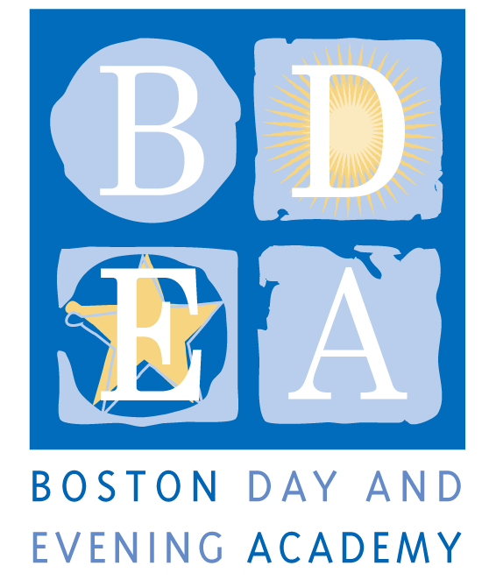
Boston Day & Evening Academy
A Horace Mann Charter School
Humanities Teacher Job Description
School Year 2018-19

Boston Day and Evening Academy (BDEA) is seeking an extraordinary Humanities Teacher to work in our school. BDEA is an innovative public high school whose mission is to serve students who are overage for grade level, many of whom have experienced life challenges that have impeded their education. Working with experienced faculty in an environment that blends strong academics and support, students are given the opportunity to earn a Boston Public Schools diploma and to reach their fullest potential through a competency-based curriculum that inspires critical and creative thinking, independent learning, and active citizenship. As a competency-based school, BDEA does not have grade levels. Our extended program, beginning at 8:00 am and running until 4:30 pm serves students with different academic needs up to age 23, including those who are being promoted from middle school without being academically prepared for high school; those who have dropped out of high school and have decided to return to earn a diploma, and those who are unable to attend regular school hours due to health issues, full time work and/or full time parenting obligations. The school employs 50 full and part-time staff to work with 405 students and is governed by an active Board of Trustees.

We are looking for a humanities teacher who is committed to working with our students, who understands the lives of urban youth and who has a track record of working successfully with students who face academic and personal challenges. BDEA teachers are expected to support students both academically and personally through academic classes, enrichment activities, and a daily advisory. Teachers work collaboratively to develop and teach a competency-based curriculum where students exhibit proficiency in multiple ways including through projects, exhibitions and other alternative means of assessment.

Responsibilities
- Teach a full course load of three – five academic classes.
- Serve as an advisor and advocate for 17 students. The role of advisor requires preparing and leading an advisory group each day, facilitating communication between the student, his or her family, other teachers, and the student support team, as well as monitoring student attendance, academic progress and overall student wellness.
- Create and maintain accurate record keeping of student academic progress and attendance on all data systems, e.g., PowerSchool and BDEA CONNECTS.
- Collaborate with other teaching staff to develop interdisciplinary and project-based curricula and alternative assessments such as portfolios and exhibitions.
- Assist with the development and implementation of individual student learning plans including special education plans (IEPs and 504s).
- Participate in the development and success of Project Month, Symposium, Portfolio Reviews, Garden Day and other community and all-school events.
- Participate in weekly program-specific and all-school meetings.
- Participate in all professional development and curriculum planning activities.
- Support and coach students to obtain passing or better score on the MCAS and other required assessments.
- Assist in developing independent projects for students in the blended and learning lab program.
- Perform other related duties to assure smooth school functioning.

Terms: BTU Group I, Full-time
As a Horace Mann Charter School, teachers and staff are paid a competitive salary in accordance with the Boston Public Schools. As a condition for employment, BDEA staff are required to sign an Election To Work Agreement (ETWA) annually, which details the terms and conditions for the work year at the school. While the school generally follows the BPS calendar, it requires additional planning time before, after or during the year, as agreed upon in the ETWA. The staff are divided into two shifts, the first shift’s staff hours are from 8:20-3:15 pm, Monday, Tuesday and Thursday and the second shift’s staff hours are from 8:55-4:15 pm, Monday, Tuesday and Thursday. Wednesday and Fridays first shift will work from 8:20 am – 3:30pm and second shift will work 9am to 3:30pm. However, hours may vary according to student needs. Common planning time, program, department and committee meetings, and professional development take place on Wednesdays and Fridays, generally between 1:30-3:30pm. This position is for the first shift (M, T, TH- 8:20-3:15pm and W, F- 9-3:30pm).

Qualifications
Required: A successful candidate will …
- Have a secondary content area certification in the State of Massachusetts. (see www.doe.mass.edu for requirements) for either ELA or History
- Have dual certification in Special Education and/or ESL
- Possess the core competencies of excellent teaching including charisma, compassion and intellectual curiosity
- Be able to interact with young people in a respectful and caring manner
- Be student/learning-centered and committed to coaching students towards success, devoting additional time to students if necessary
- Commitment to designing and implementing a competency based curriculum
- Be able to assess student competency in multiple ways
- Create a learning environment where the teacher is coach and student is worker
- Have the ability to teach to multiple learning styles using a variety of methods
- Have a commitment to working with the families of our students and with parenting students
- Adhere to BDEA’s Non-Discrimination Policy (see below)

Preferred:
- Masters Degree a strong plus
- Prior work or volunteer experience with non-traditional students in an alternative setting
- Comfortable with a workshop and/or coaching approach to instruction
- Experience with any of the following: project-based learning, portfolio assessment, competency-based education, cooperative group work, integration of technology and cross disciplinary learning, expeditionary learning, alternative assessments and integrating school to career experiences into the curriculum
- A strong commitment to supporting reading, writing and problem solving across the curriculum
- A sense of humor

Application Procedure
Apply through Boston Public Schools’ Human Capital website: http://bostonpublicschools.org/Page/4637

Boston Day and Evening Academy, in accordance with its non-discrimination and zero tolerance policy, does not discriminate in its programs, activities, facilities, employment and educational opportunities on the basis of race, color, age, disability, sex/gender, gender identity or expression, religious beliefs, national origin, ancestry, retaliation, sexual orientation, genetics or military status and does not tolerate any form of intimidation, threat, coercion and/or harassment that insults the dignity of others and interferes with their freedom to learn or work.

